- Home

- State Running Schemes
UPSDM has been established to make the youth employable by providing free vocational training. It is the first effort of its kind to run five Central Government & one state Government skill development schemes in integrated & uniformly standardized way. Privilege has been given to weaker sections of society i.e. scheduled caste, minority, women & BPL candidates etc. The candidate must be the resident of Uttar Pradesh and should have age falling in 14- 35 years age group (for BOCW scheme, upper limit is extended to 50 years). However, an overall coverage of 20% candidates from minorities and 30% women candidates is mandated, taken all the schemes together. Besides this a State skill Development Fund (a Top-up fund) is created to meet out the additional expenses needed in order to ensure integration. Following the common minimum norms adopted by mission 70% of the successfully certified candidates will be the minimum target for placement, out of which wage employment should be not less than 50% in any case.
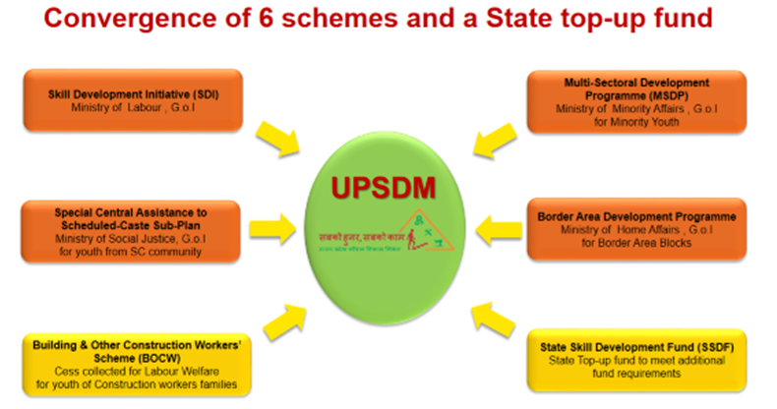

SCHEMES, DIAGNOSIS
1 | Skill Development Initiative (SDI) : Scheme of Ministry of Skill Development and Entrepreneurship, Government of India for skilling all. | Finance: Completely funded by GOI  Course standards offered: MES only  Eligibility Criteria: 14-35 years age group youth of all categories  Reservation/ Priority criteria: to ensure 30% women participation  Placement Criteria: At least 75% placement
2 | Special Central Assistance to Scheduled-Caste Sub-Plan (SCA to SCSP) : Scheme of Ministry of Social Justice and Empowerment, GoI for skilling youth from SC/ST community. | Finance: Completely funded by GOI  Course standards offered: MES & QP- NOS both  Eligibility Criteria: 14-35 Years age group youth who belongs to scheduled caste only  Priority criteria: 30% women participation to be ensured  Placement Criteria: NA
3 | Multi- Sectoral Development Programme (MSDP) : Scheme of Ministry of Minority Affairs, GoI for skilling Minority Youth | Finance: Completely funded by GOI  Course standards offered: MES only  Eligibility Criteria: Minority candidates (Muslims, Sikh, Jain, Parsee, Cristian & Buddhist)in the age group of 14-35 years residing in the 137 Blocks & 17 town areas of 46 selected districts of UP.  Reservation/ Priority criteria: 33% women participation to be ensured  Placement Criteria: At least 75% placement
4 | Border Area Development Programme (BADP) : Scheme of Ministry of Home Affairs, GoI for skilling Border Area Blocks resident youths | Finance: Completely funded by GOI  Course standards offered: MES & QP- NOS both  Eligibility Criteria: Residents of 19 blocks of seven districts sharing international border with Nepal.  Priority criteria: 50% women participation to be ensured  Placement Criteria: NA
5 | Building & Other Construction Workers’ Scheme (BOCW) : Scheme under Labour Department, GoUP for skilling youth of Construction workers families through Labour Welfare Cess | Finance: Completely Funded by Government of Uttar Pradesh.  Course standards offered: MES & QP- NOS both  Eligibility Criteria: Candidate with age group of 14-50 years, registered with BOCW (Building & other construction workers) welfare board and his dependent family members including wife, dependent unmarried daughter & son below age of 21 years.  Priority criteria: NA  Placement Criteria: NA
6 | State Skill Development Fund (SSDF) : UP State Top-up fund created to meet additional fund requirements (top-up) for different integrated schemes. Also used for training purpose under specific conditions & for non-priority category of candidates. | Finance: All Uttar Pradesh resident with age group of 14-35 years.  Course standards offered: MES & QP- NOS both  Reservation/ Priority criteria: 20% minorities & 30% women participation targeted  Placement Criteria: At least 60% placement

